**Name: PARMESH YADAV**

**Roll No: 2020319**

**SCIENTIFIC COMPUTING (MTH373)**

**HOMEWORK – 2**

Problem – 1

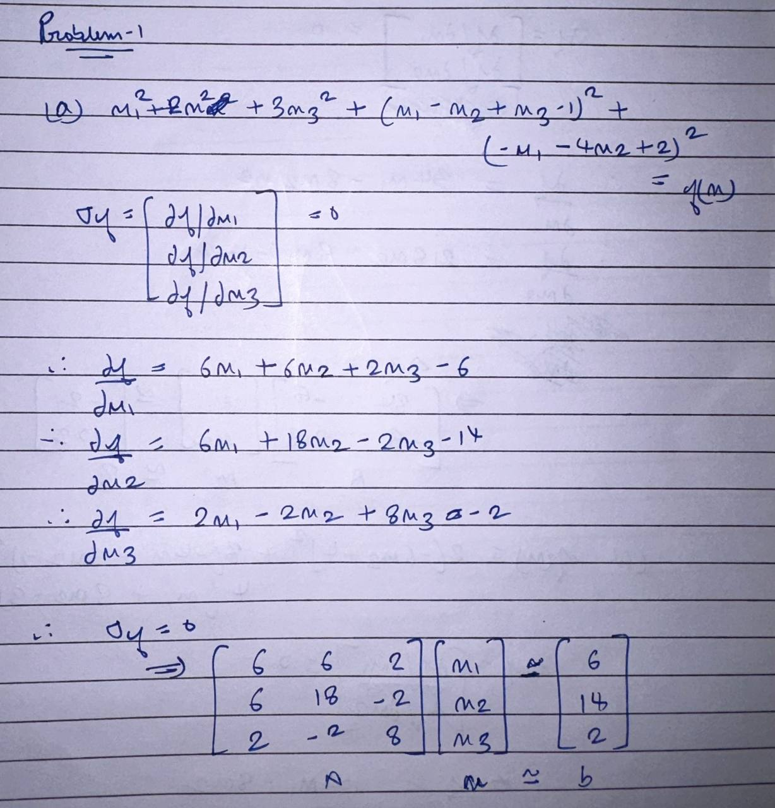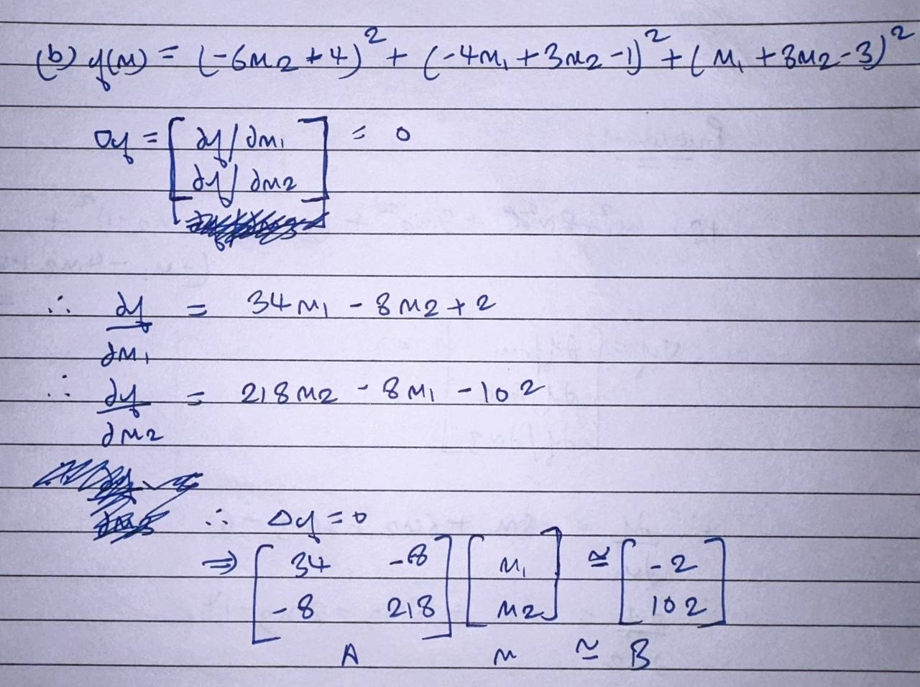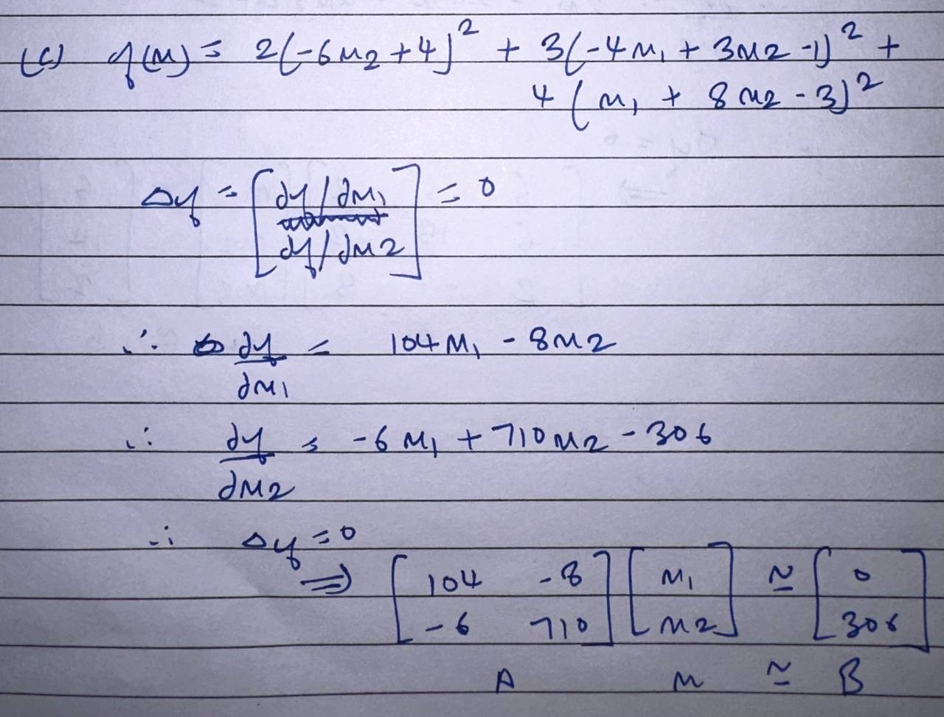

Problem – 2

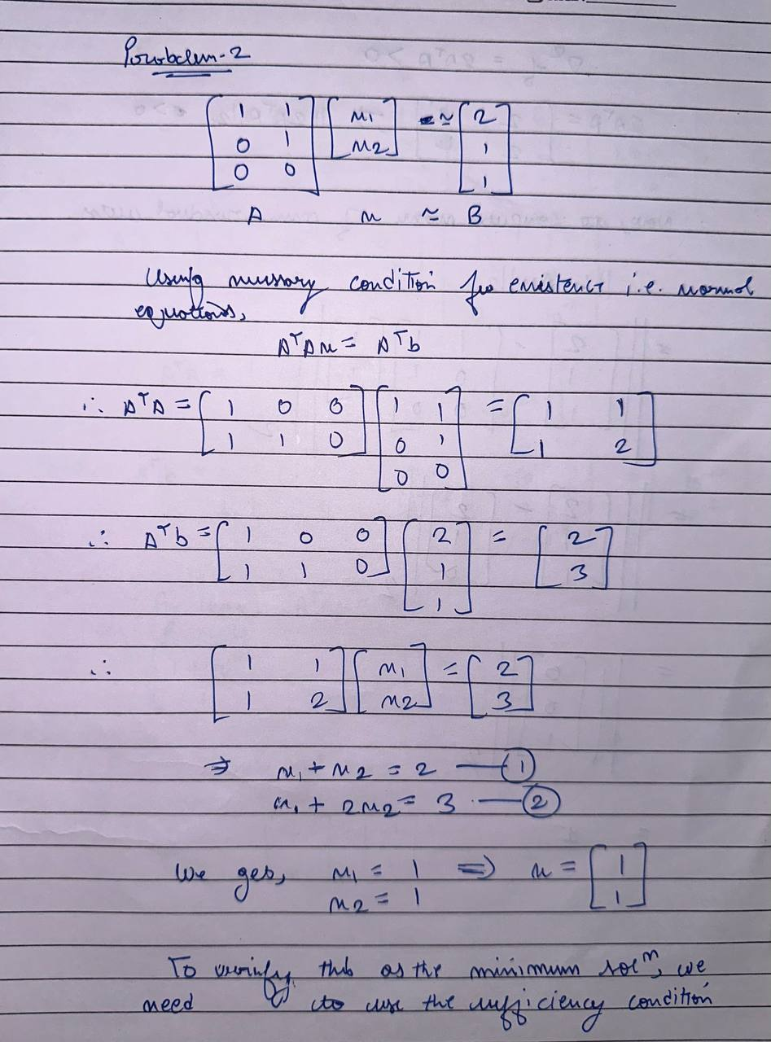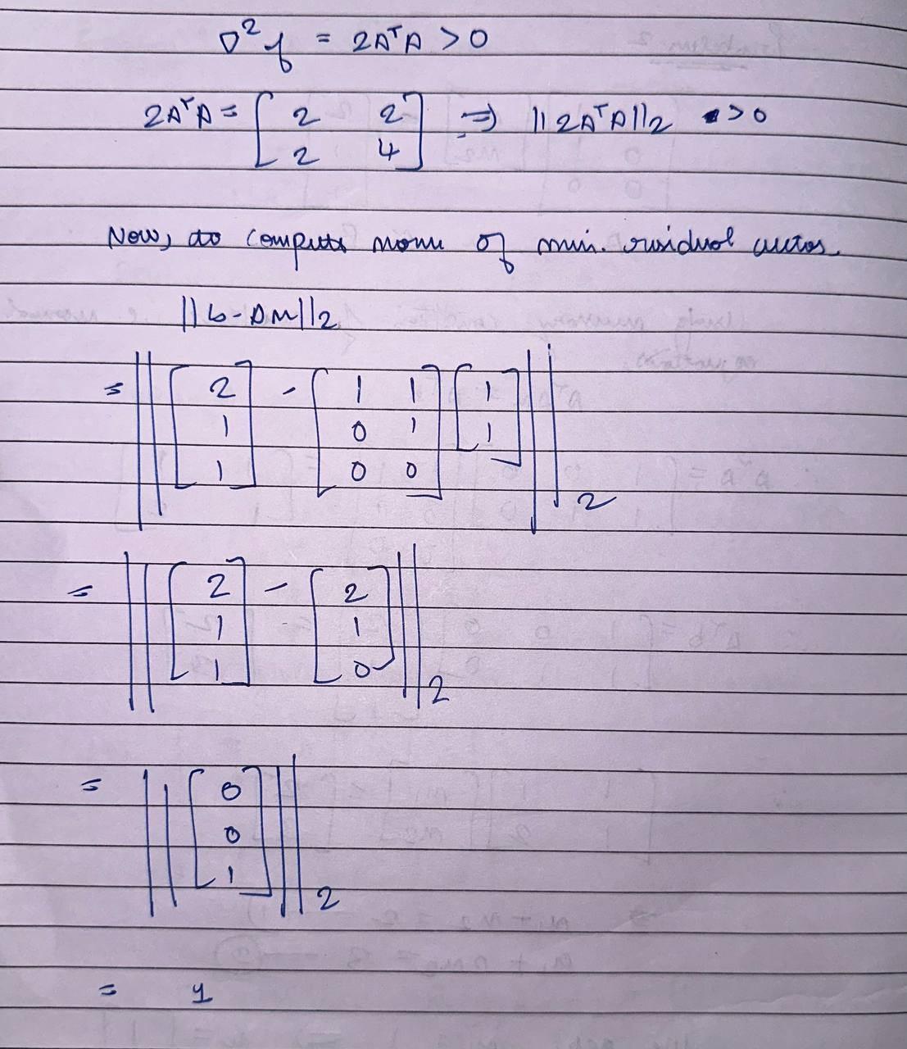

Problem – 3

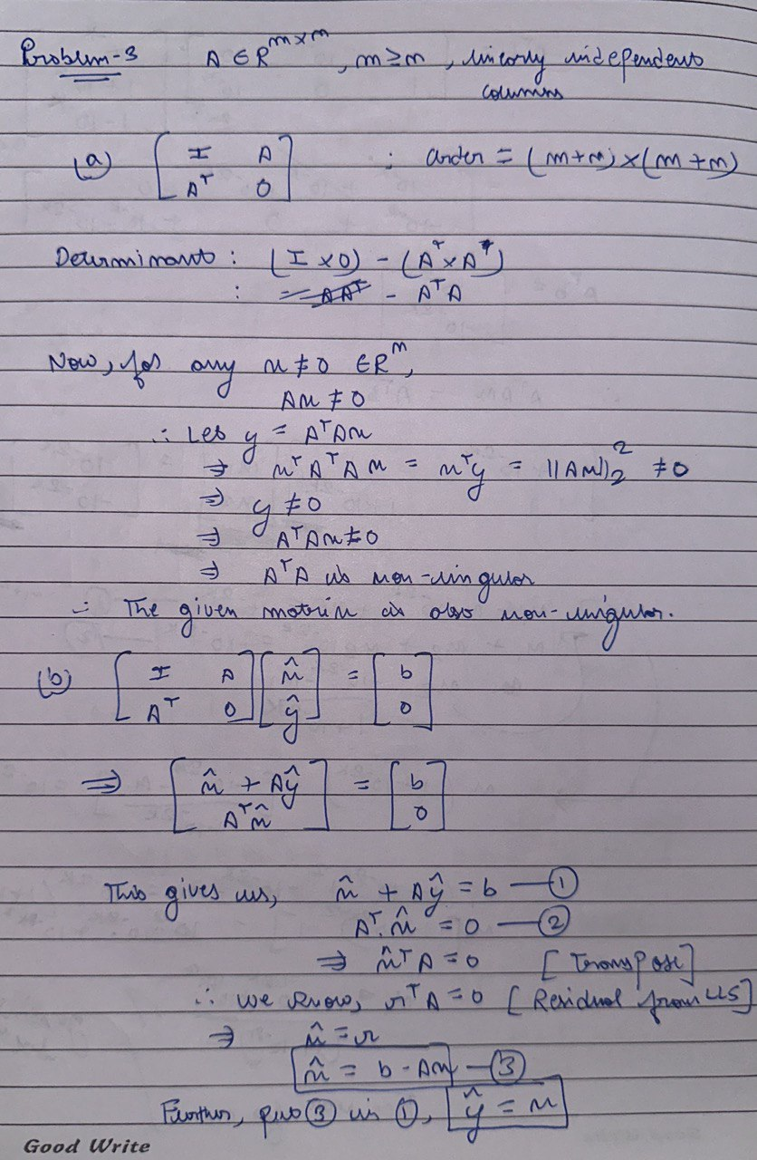

Problem – 5

a)

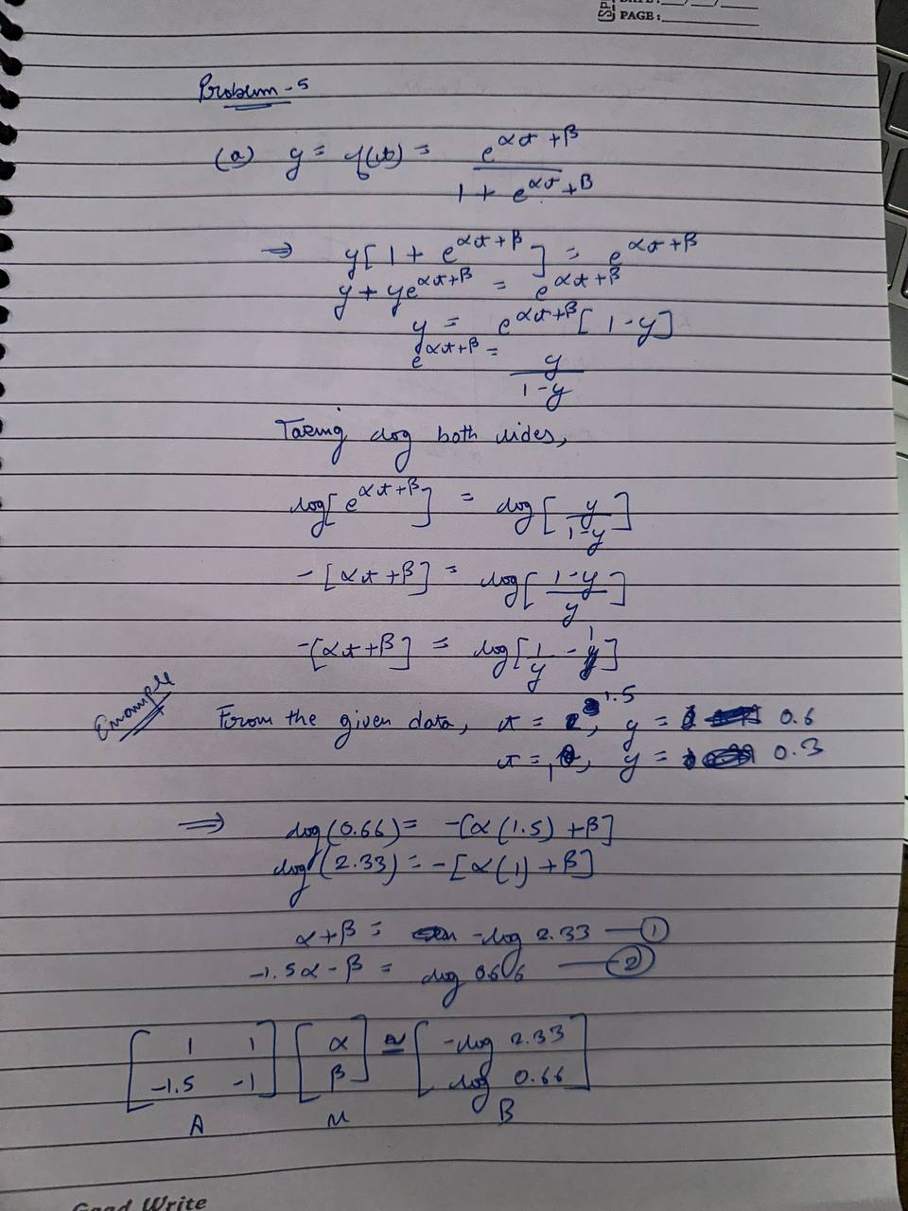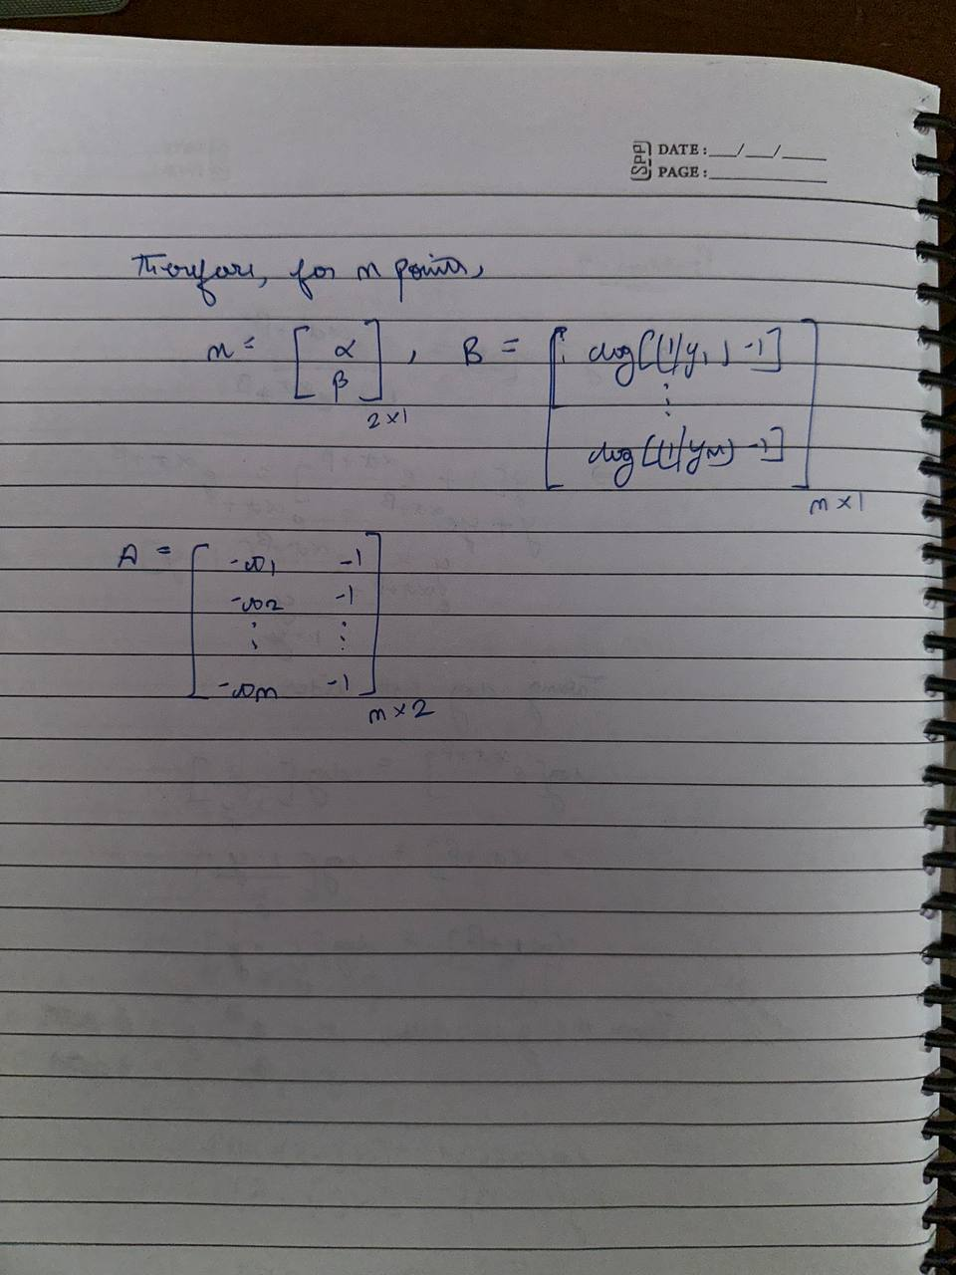

b)

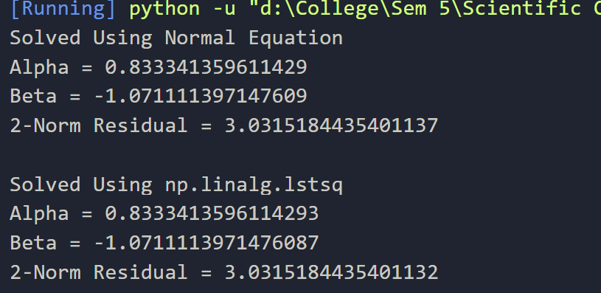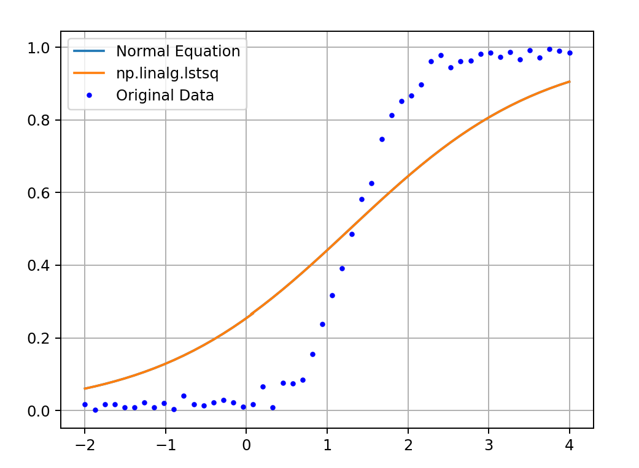

As the difference between the 2 solutions, one by normal equations and the other by np.linalg.lstsq is very low, the plots overlap, hence, only one is visible.

Problem – 6

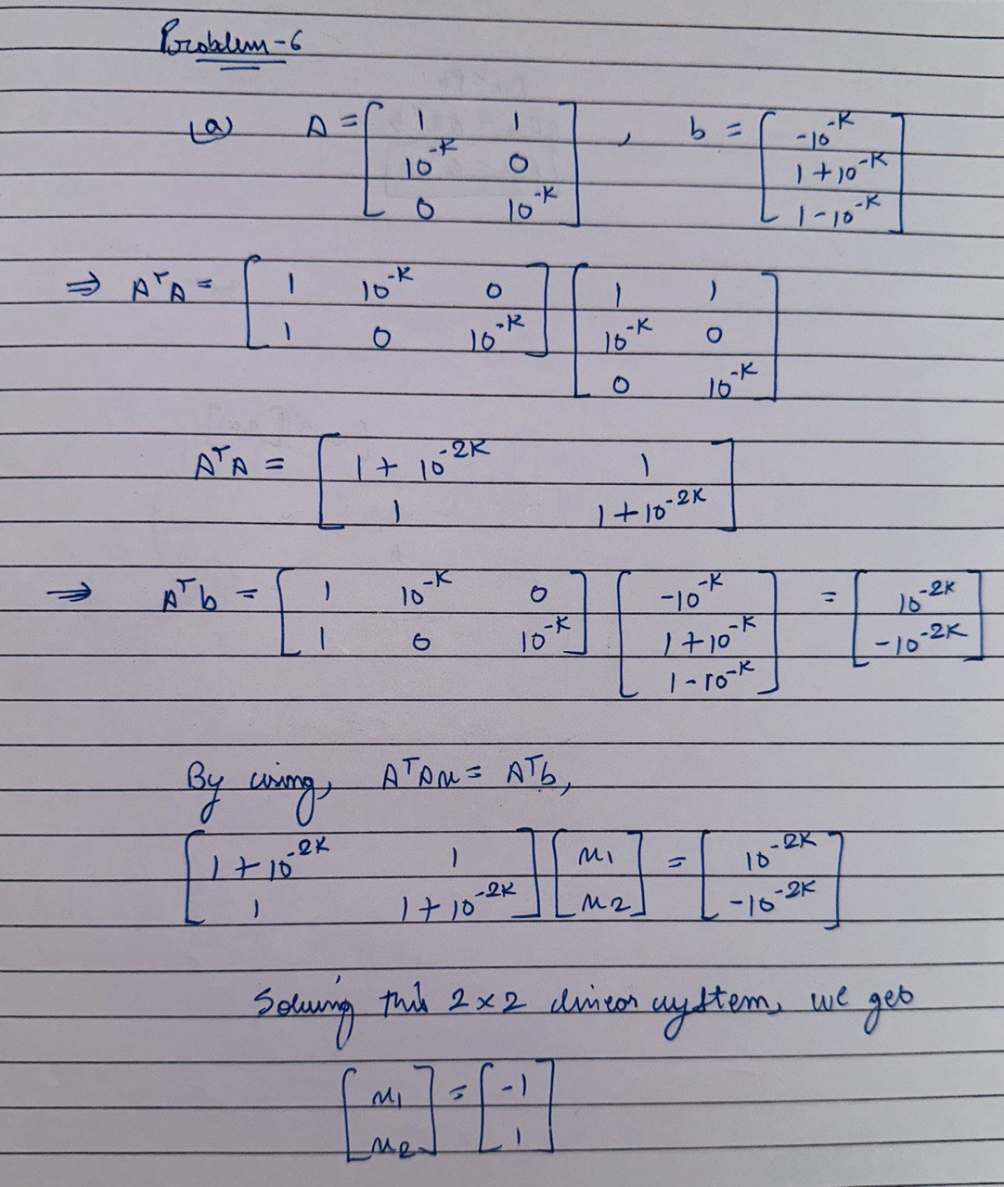

Using QR Decomposition (6_B) Using Normal Equations(6_c)

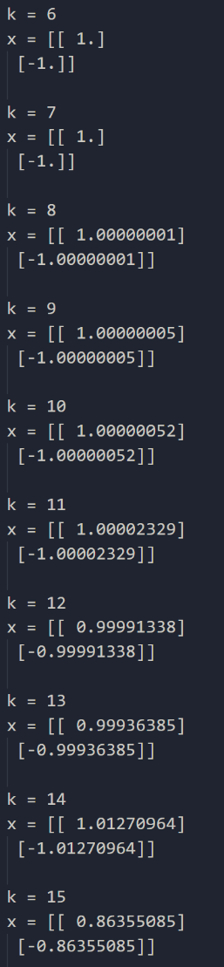 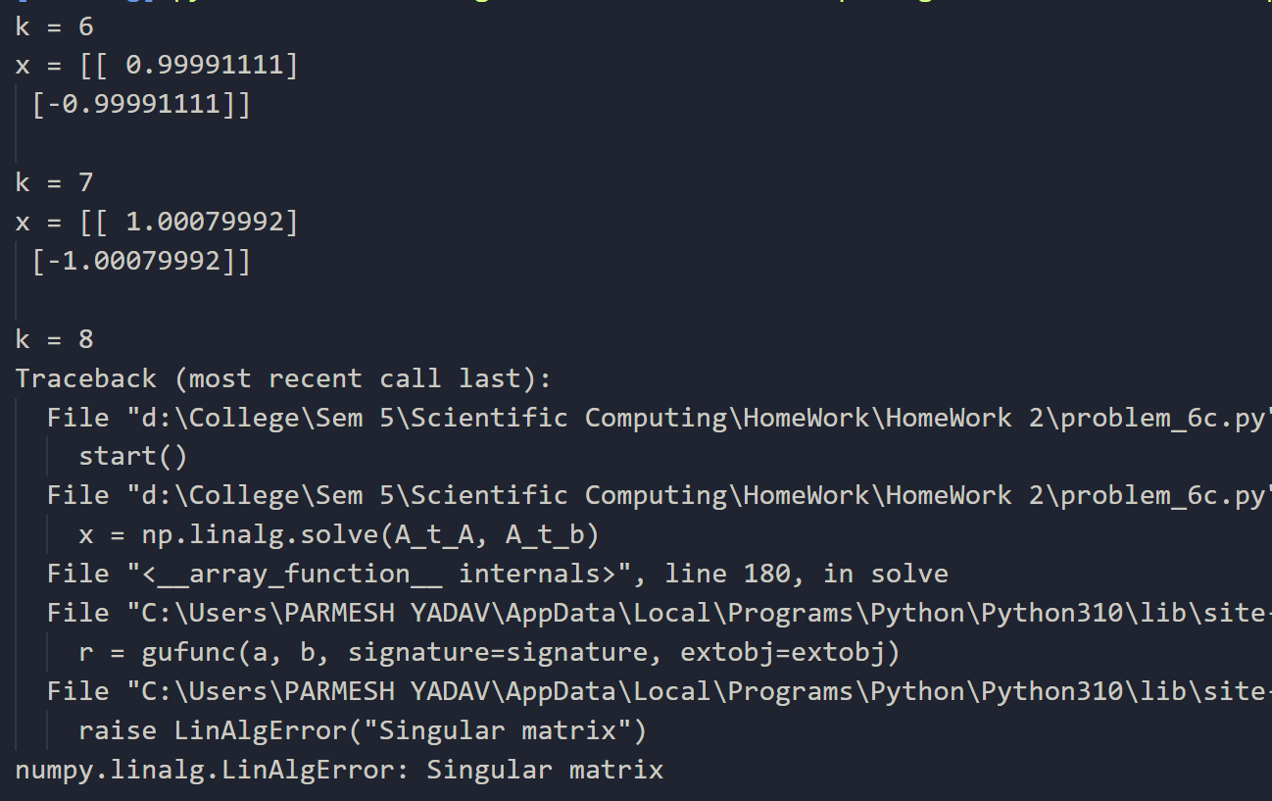

As we can see in both the outputs, as the value of K increases, the perturbation in the final answers also increases. In the second case i.e., solving using Normal Equation, for K >= 8, the matrix ATA becomes singular.

Problem – 7

Output

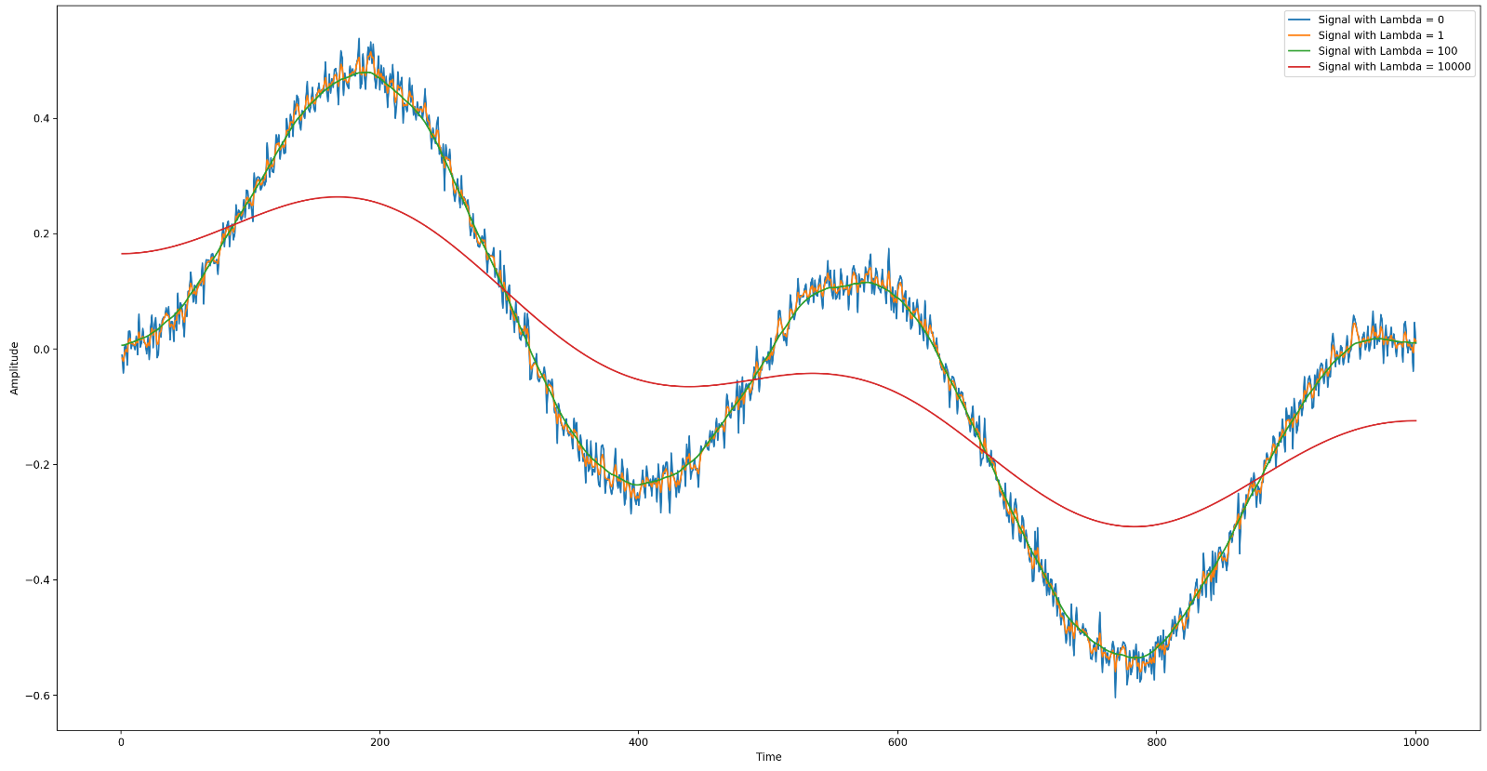

As we can see in the output, the blue line represents the original signal and the orange, green and red represent the 3 reconstructed signals for lambda = 1,100,10000.

We can observe that for lambda = 1 [Orange], the reconstruction is not very useful, it’s still having noise in it. The most accurate reconstruction is for lambda = 100 [Green] and as lambda increases to lambda = 10000 [Red], the output doesn’t have noise but is perturbed very much from the original signal.